ST. XAVIER’S COLLEGE

**(Affiliated to Tribhuvan University)**

Maitighar, Kathmandu



**Computer Graphics Lab Assignment #3**

**Submitted by:**

Pratibha Panta

013BSCCSIT028

**Submitted to:**

|  |  |
| --- | --- |
| Er. Anil Sah  Lecturer, St. Xavier’s College |  |

**DDA Algorithm**

**Algorithm:**

step 1: start

step 2: Input a,b,and d

Step 3: dx=c-a

dy=d-b

Step 4: if if(abs(dx)>abs(dy))

step 5: steps=abs(dx);

else

steps=abs(dy);

step 6: incrx=dx/steps;

incry=dy/steps;

step 7: x=a;

y=b;

Step 8: Image1->Canvas->Pixels[x][y]=RGB(150,100,125);

step 9:If k<=steps

Step 10: x=x+incrx;

y=y+incry;

Step 11: Image1->Canvas->Pixels[x][y]=RGB(150,100,125);

Step 12: Increase k

Step 13 :End

**Program Code:**

//---------------------------------------------------------------------------

#include <vcl\vcl.h>

#pragma hdrstop

#include "Unit1.h"

//---------------------------------------------------------------------------

#pragma resource "*.dfm"

TForm1 *Form1;

int a,b,c,d,dx,dy,steps,k;

float incrx,incry,x,y;

//---------------------------------------------------------------------------

__fastcall TForm1::TForm1(TComponent* Owner)

: TForm(Owner)

{

}

//---------------------------------------------------------------------------

void __fastcall TForm1::DDAClick(TObject *Sender)

{

a=StrToInt(Edit1->Text);

b=StrToInt(Edit2->Text);

c=StrToInt(Edit3->Text);

d=StrToInt(Edit4->Text);

dx=c-a;

dy=d-b;

if(abs(dx)>abs(dy))

steps=abs(dx);

else

steps=abs(dy);

incrx=dx/steps;

incry=dy/steps;

x=a;

y=b;

Image1->Canvas->Pixels[x][y]=RGB(150,100,125);

for(k=1;k<=steps;k++)

{

x=x+incrx;

y=y+incry;

Image1->Canvas->Pixels[x][y]=RGB(150,100,125);

}

}

//--------------------------------------------------------

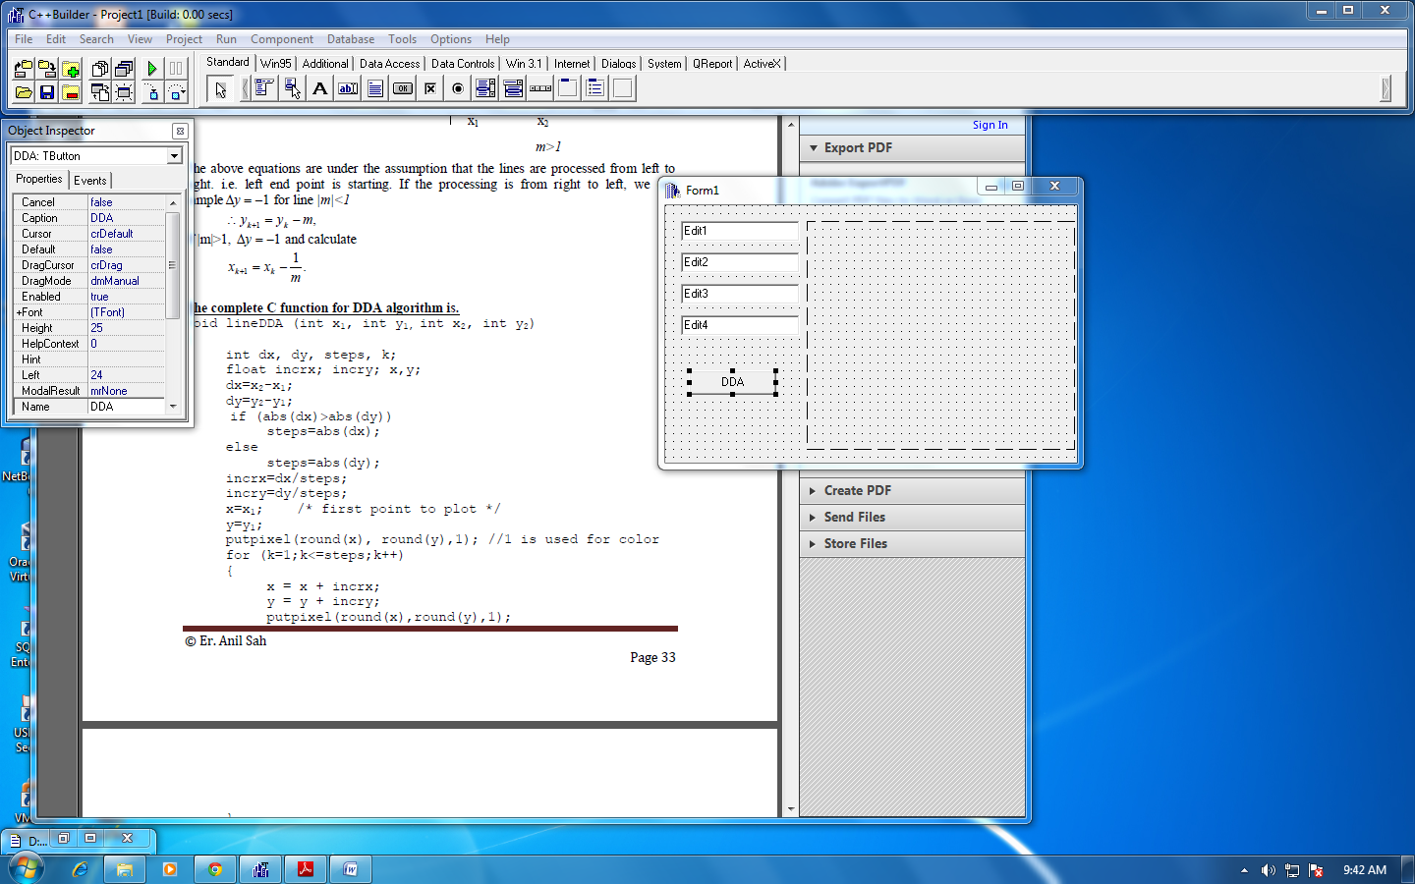

**OUTPUT**

